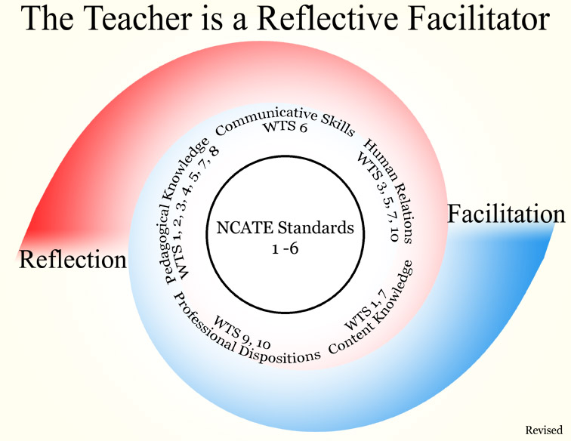

Our conceptual framework, The Teacher is a Reflective Facilitator, is the underlying structure in our teacher preparation program at UW-Whitewater that gives conceptual meanings through an articulated rationale to our operation. It also provides direction for our licensure programs, courses, teaching, candidate performance, faculty scholarship and service, and unit accountability. In short, our teacher education program is committed to reflection upon practice; to facilitation of creative learning experiences for pupils; to constructivism in that all learners must take an active role in their own learning; to information and technology literacy; to diversity; and to inquiry (research/scholarship) and assessment. Therefore, all syllabi pertaining to courses required for licensure reflect commitment to these underlying principles.

UNIVERSITY OF WISCONSIN-WHITEWATER
DEPARTMENT OF COMMUNICATIVE DISORDERS

ComDis424/624: Organic Speech Disorders

Instructor: Ruiying Ding, Ph.D., CCC-SLP Semester: Fall, 2005
Office: Roseman 1022 Class Time: T,Th 12:30-1:45 PM
Phone: 262-472-5201 Classroom: R1040
E-mail: dingr@uww.edu Office Hours:T,Th 10-12AM

I. COURSE DESCRIPTION:

This course provides a basic understanding of how structural malformations of the vocal tract influence speech and voice production. The primary focus of study is on applying the principals of speech and voice science to communication deficits associated with structural changes in the vocal tract (for example, voice disorders, cleft palate speech disorders, and swallowing dysfunction). Prerequisite: 510-375 Speech Science II: Speech Acoustics, Speech Physiology, and Speech perception, or consent of instructor.

II. COURSE OBJECTIVES:
The purpose of this course is to develop a theoretical framework and basic understanding of speech disorders. Goals are in compliance with the Department of Communicative Disorders Assessment Plan to assess Knowledge=K, Skills =SK and Dispositions=D which are aligned with the Council on Academic Accreditation Standards in Speech Language Pathology (CAA), see ( ) items; and PI 34 Wisconsin Teaching Standards [WTS], see [ ] items.
The specific course objectives include the following:

A. Knowledge/Content K1, K2, K3, D1, (1a, e, f, 2 a-c, f, I, 3 a-e, 4 a-c, 5 d, 6 a-e, 8, 9), [III-C,D,E)
1. To demonstrate knowledge of basic human communication and swallowing processes, including their biological, neurological, psychological and cultural bases K1 (III-B)
1. To review anatomy and physiology of speech and to apply this knowledge to speech disorders due to structure deficits K1 (III-C).
2. To describe basic knowledge of fluency and stuttering and its treatment principal K2 (III-D, E) [1, 2, 3, 7, 8]
3. To describe voice and its disorders and its treatment principals K2 (III-D, E) [1,2,3,7, 8].
4. To describe speech disorders associated with cleft palate and its treatment principals K2 (III-D, E) [1,2,3,7,8].
5. To describe the oral, pharyngeal, and esophageal behaviors associated with normal swallowing and with dysphagia associated with structural problems K2 (III-D, E, G) [1,2,3,7,8].
6. To analyze all disorders with multi-cultural point of view K2 (III-D, E) [1, 2, 3, 7, 8, 10].

B. Skills
1. To utilize anatomical and physiological principals to understand various communicative disorders SK1, D1.
1. To evaluate fluency disorders and design treatment principals SK1, D1.
2..To describe perceptual characteristics of voice disorders and design treatments SK1,D1.
3. To describe orofacial disorders such as cleft palate and design treatments SK1, D1.
4. To complete oral facial examination and report findings in a report format SK1, D1.
5. To describe normal anatomy and physiology of swallowing disorders and design treatment based on the findings from videofluoroscopic studies SK1, D1.

III. COURSE FORMAT:

Class activities will include lectures, readings, videotapes, software labs, discussions, lab tests, group presentation, and in-class examinations. Details about these activities will be forthcoming in lectures and in handouts provided during the semester.

IV. COURSE REQUIRMENTS:

A. Required Text:
1. Hedge, M.N.: Introduction to Communicative Disorders. Austin, TX, 2001, Pro-Ed.
2. Ferrrand C.I., & Bloom, R.L.: Introduction to Organic and Neurogenic Disorders of Communication: Current Scope of Practice, Boston, 1997, Allyn& Bacon.

B. Support Texts:
1. Greene M.C.L. & Mathieson L: The voice and its disorders. San Diego, CA, 1992, Singular Publishing.
2. Peterson-Falzone S.J., Hardin-Jones M.A., & Karnell M.P.: Cleft palate speech. Philadelphia, 2001, Mosby.
3. Logemann JA: Evaluation and treatment of swallowing disorders. Austin, TX, 1998, Pro-Ed.
3. Owens, R., Metz, D., & Haas, A.: Introduction to Communication Disorders: A Life Span Perceptive. Boston, 2000, Allyn & Bacon.

V. COURSE SCHEDULE:

Week# Date Topic Schedule
1 Sep. 6/8 Introduction, Anatomy & Physiology of Speech
2 Sep. 13/15 Anatomy & Physiology of Speech cont'd
3 Sep. 20 Anatomy & Physiology of Speech cont'd
Sep 22 Examination
4 Sep. 27/29 Fluency
5 Oct. 4/6 Fluency Cont’d
6 Oct. 11/13 Voice Disorders
7 Oct. 18/20 Voice Disorders Cont’d

8 Oct. 25 Examination
Oct. 27 Cleft Palate
9 Nov 1/3 Cleft Palate
10 Nov 8 Cleft Palate
Nov 10 Examination
11 Nov. 15/17 Swallow Disorder
12 Nov. 22/24* Swallow Disorder Cont'd
13 Nov. 29, Dec 1 Swallow Disorder Cont'd
14 Dec 6/8 Student Presentation
15 Dec. 13/15 Final Examination
16 Dec. 20/22 Review of Examination

There will be a lab test within each examination.

** No class-Thanksgiving

Graduate students who registered in this class are required to do additional course work to reflect increased requirement in content, intensity and self-direction. Graduate students will be required to attend additional observation sessions to learn specific treatment techniques in fluency, voice and/or cleft palate. An additional research paper in diagnosis of organic speech disorders is also required.

VI. GRADING SYSTEM:
Undergradautes
Examinations 1-3 3X100 points
Student Presentation 50 points
Final Examination 100 points

Graduates
Examinations 1-3 3X100 points
Student Presentation 50 points
Research paper 50 points
Final Examination 100 points

VII. GRADING COMPOSITION:

Grade determined by: Points earned divided by total points possible X100= percentage
PERCENTAGES
A=90-100
B=80-89
C=70-79
D=55-69
F=below 55

VIII. UNIVERSITY AND INSTRUCTION POLICY:

A. Class Attendance: You are expected to attend to all classes, however, if you are unable to attend, please talk to me in advance if possible so that I can arrange for notes to come to you from a classmate.

B. Class Participation: You are expected to participate in class discussion and group projects.

C. Course Compliance with DPI and INTASC Standards: This course meets the DPI Communicative Disorders requirements PI 4.78 (2), and PI 4.78 (7) and is in compliance with the interstate New Teacher Assessment and Support Consortium (INTASC) Standards, specifically Principles #1-10.

D. University Policy Regarding Individual Accommodations and Misconduct:
The University of Wisconsin-Whitewater is dedicated to a safe, supportive, and non-discriminatory learning environment. It is the responsibility of all undergraduate and graduate students to familiarize themselves with University policies regarding Special Accommodations, Misconduct, Religious Beliefs Accommodation, Discrimination, and Absence for University Sponsored Events. (For details please refer to the Undergraduate and Graduate Timetables; the "Rights and Responsibilities" section of the Undergraduate Bulletin; the Academic Requirements and Policies and the Facilities and Services sections of the Graduate Bulletin; the "Student Academic Disciplinary Procedures" [UWS Chapter 14]; and the "Student Nonacademic Disciplinary Procedures" [UWS Chapter 17]).

E. Syllabus Change: Students are responsible for any syllabus changes announced in class, via e-mail, via Blackboard, or in writing.

