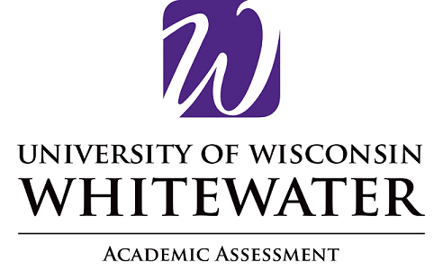

Program Name

Mission Statement
(Type/Paste here)

Student Learning Outcomes

Student learning outcomes (SLOs) are statements of what a student will know or be able to do when they have completed a program. They represent the knowledge and skills a program has determined are most important for students to gain from that program. The most useful SLOs are specific and measurable so the program can accurately assess the degree to which students have achieved each outcome, and they align with college and institution mission and values. Data on achievement of SLOs is used to make improvements in the program and increase student success.
(Type/Paste here)

