Cost Transfer Workflow Tool – Non-Salary Cost Transfer via WISER

Table of Contents
Cost Transfer Tool Overview 3
What is it? 3
Features 3
Salary Cost Transfers (SCT) vs. Non-Salary Cost Transfers (NSCT) 3
Resources 3
Creating a New Non-Salary Cost Transfer Via WISER 4
Pulling the “From” side via WISER 4
Entering the “To” Side of the Cost Transfer Transaction 5
Check for Errors 6
Documentation Tab 6
90 Days after the Original Transaction - Documentation/Comments/Justification 6
NSCT Routing, Edit Rights and Ownership 7
History of the Transfer 8
Home 8
Dashboard View –Preparers of Non-Salary Cost Transfers 8
Searching for Transfers 9
Validations 10
Workflow After Submitted 10
Person Resolution 10
Other Aspects to Workflow and Approval 11

Cost Transfer Tool Overview

What is it?
- The Cost Transfer Tool is designed to make a balanced transfer of accounting from one funding source to another.

Features
- Gives the user the ability to search WISER to select transaction(s) that need to be transferred.
  - This step also eliminates tedious entry
- Validations are performed to ensure the data is clean and valid when going to the General Ledger (GL).
- Provides a custom workflow that requests signatures for approval based on the content of the transfer
- Provides search features so users can find transfers they have made in the past.
- Integrates to WISER so that when looking at a transaction in WISER, a transfer can be initiated right from the reporting system.

Salary Cost Transfers (SCT) vs. Non-Salary Cost Transfers (NSCT)
Cost transfers are divided into two forms – salary and non-salary. Each cost transfer has a transfer number which acts like a unique business key. Salary transfers begin with “S” and non-salary begins with “N”, followed by a unique sequence number. This document only goes over non-salary transfers. PLEASE NOTE: at this time UW-Whitewater will only be utilizing the NSCT. A Salary Cost Transfer must still be submitted via the Change of Status system and Student Employment Tool.

Resources
There are several resources available to help you progress through the Cost Transfer Workflow Tool that you can use when you encounter problems, have specific questions, or desire to provide feedback:
- Help Icon: for immediate assistance, click on the help icon found on most screens within the Cost Transfer Workflow Tool itself. Many of your questions may be answered right here.

2. Cost Transfer Support:

Name: Email: Phone:
Jodi Sumpter sumpterj@uww.edu 262-472-5785
Rebecca Baranowski BaranowskiRL16@uww.edu 262-472-1191

Creating a New Non-Salary Cost Transfer Via WISER
A transfer can be initiated right from WISER. The transaction is loaded into Cost Transfer Tool and basic metadata is requested. This allows users to initiate a transfer when they see the need in the system where they are examining data from rather than looking in WISER and then repeating the same search in Cost Transfer Tool. This works for SCT and NSCTs.

Pulling the “From” side via WISER
- Login to WISER
- Click Main Menu on the top left corner
- Choose Find Detailed Transactions
  - If you need your specific funding string, click Find Departments to view
- Fill out enough data to find transaction (year, fund, dept, journal ID, project, etc)
- Click Search
- Find the correct transaction and then click on the magnifier icon to the right
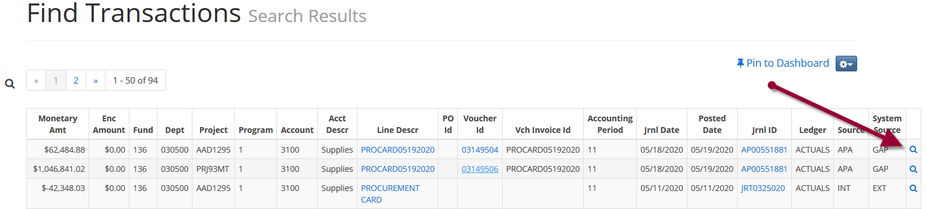
- Click on Cost Transfer Tool
  - This will grab this transaction and move it into your Basket
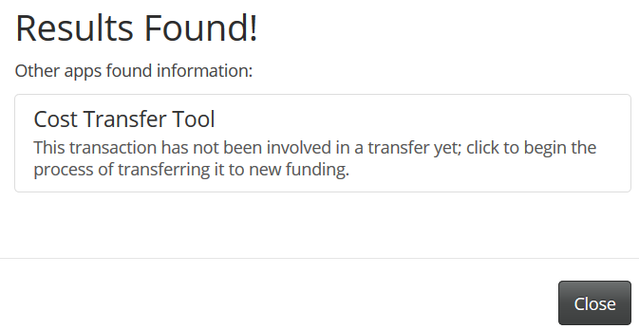
- The Basket then appears on the left side of your screen, enter the details of the transfer, and click on Create
  - This will create a NSCT #
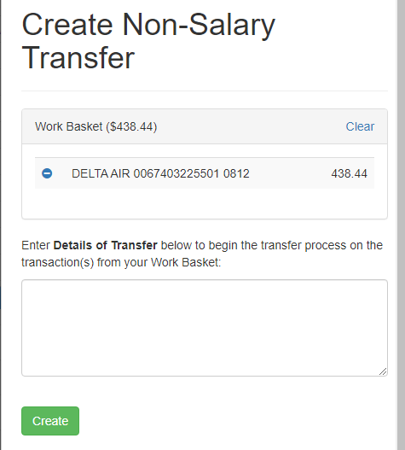
- Click on Go to this transfer
  - This will open the transfer in the Cost Transfer Tool (CTT) System
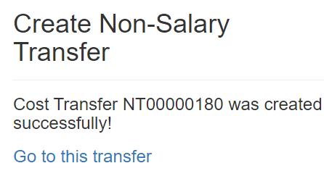

Entering the “To” Side of the Cost Transfer Transaction
- Enter Dept ID, Fund, Program (if required), Account information in the To section
  - As you enter the Transfer To account information, you may find it useful to use the Copy to all function to update all the To lines.
- Add the Amount being transferred over as well as the Description
  - Decreasing the “From” amount is considered a “partial” transfer.
  - The Cost Transfer Tool does not allow the “from” to be changed to an amount that is more than the original expense.
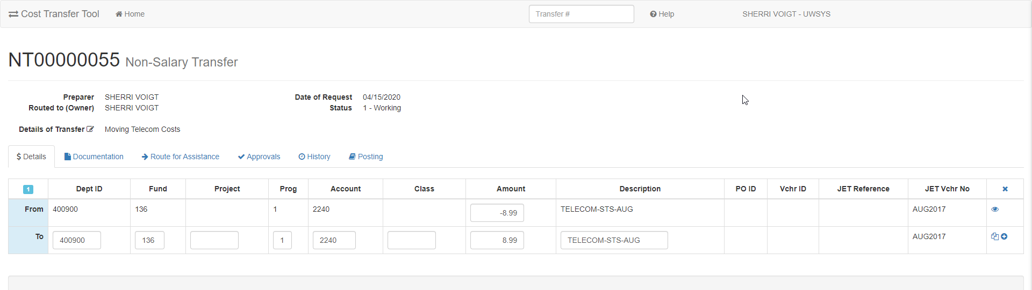

Screen Icon key:
View more detail – additional fields from WISER are displayed
Copy to all – Dept ID, Fund, Project copied to all to lines
Split – add a To line to split the From transaction

Check for Errors
- Use the Check for Errors function on the bottom left
  - Checking for Errors validates the funding string and enforces balanced accounting.
  - It will also calculate the applicability of the >90-day rule (i.e., >90 days have passed from the end of the month that the original expense posted) and require that a justification be completed.

Documentation Tab
- Click on the Documentation Tab
  - Click on Add Attachments and add supporting documents for the proposed transfer
    - Note: WISER documentation is NOT REQUIRED, as the tool validates the authenticity of the From.
  - Click Add Comments and add all supporting information for the proposed transfer
    - Note: Comments that are included with routing and rejections are stored here
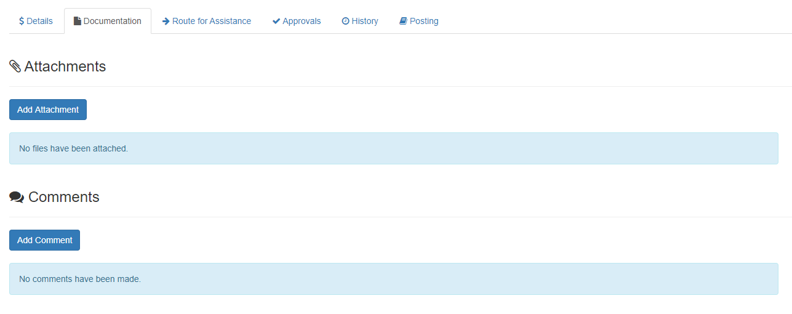

90 Days after the Original Transaction - Documentation/Comments/Justification
- If the transfer is over 90 days, the preparer will be automatically be required to fill out the justification. This can be viewed in the Documentation Tab.
  - 90 Day period is technically 90 days from the end of the month a transaction is posted.
  - Below is an example of a 90-day Transfer Justification
- Click Save Justification on the bottom once the fields are completed
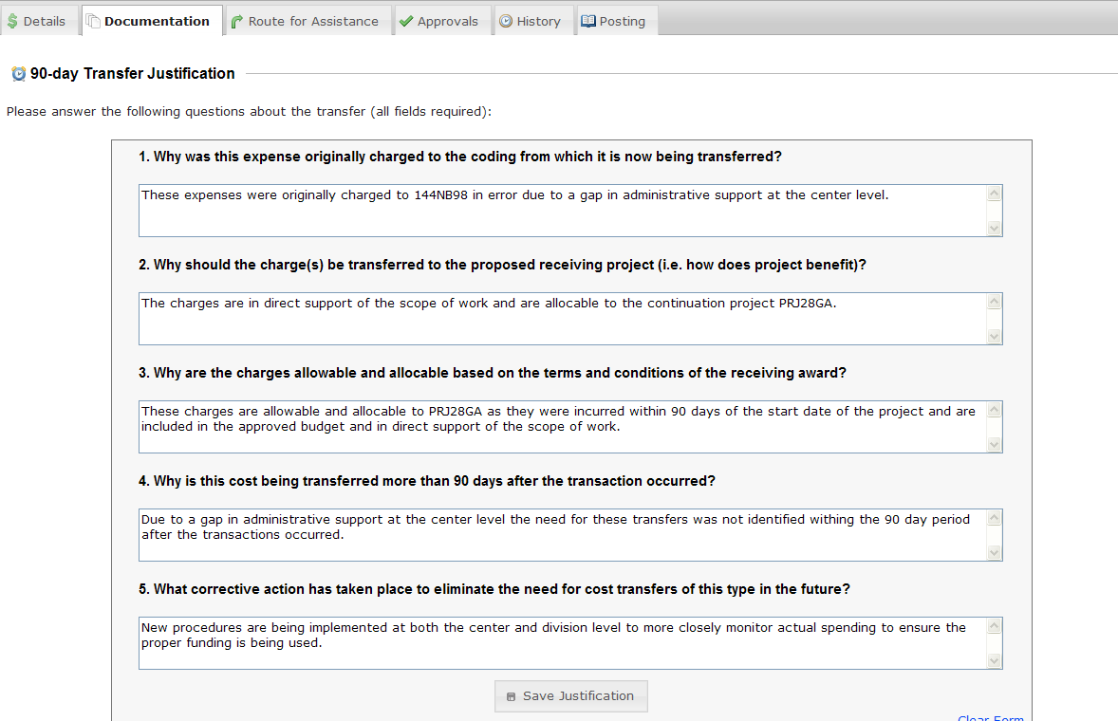

NSCT Routing, Edit Rights and Ownership
- If additional information is needed, add Routing person’s name
  - This is not required
  - “Routing” is intended for assistance or to accommodate a department’s internal workflow. Routing a record gives permission to edit the cost transfer record. The person you route to will be notified by email of this action and the transfer record will appear in their worklist.
  - Note: Routing is not used to collect approval signatures.
  - Note: Routing transfers ownership. The preparer no longer has edits rights when a transfer is routed to another user or submitted for approval.
- Add any Comments that may be needed for the person it will be routed to
- Click Route to this Person
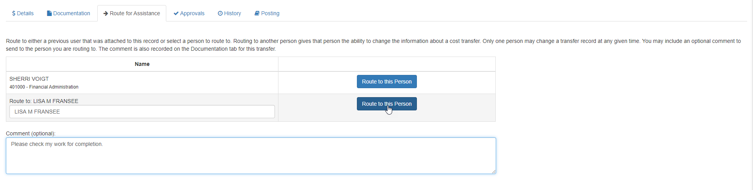
  - The follow is an example of what the automatic email notifications will be:
    - Note: a direct link to the transfer record within the Cost Transfer Workflow Tool is embedded in the email.
*** Original intended recipients: Barnie Rubble ***
A cost transfer has been routed to you.
You may edit transfer ST00000032 by following this link: https://www.ct.sfs.services.wisc.edu/sct/32
Transfer Synopsis:
Created by: Fred Flinstone
Created on: 3/31/2020
Details of transfer: Test.
- The owner of the record routed to can Submit for Approval
  - Once submitted, the status changes to 2-Waiting for Approvals.
  - The tool determines the required signatures and automatically notifies the approvers.

History of the Transfer
- Check the History tab to see all major events, which are captured and retained here
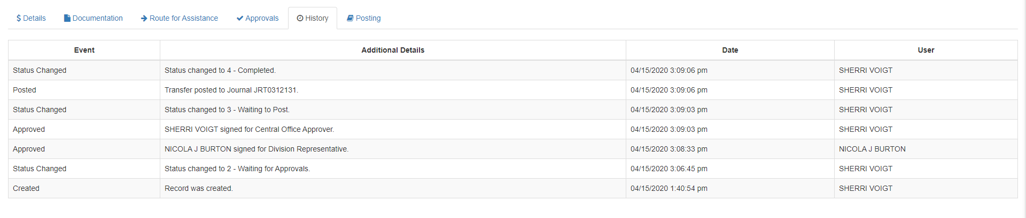

Home
- The Home button in the upper left corner will return you to the Dashboard of the Cost Transfer Tool

Dashboard View –Preparers of Non-Salary Cost Transfers
- You will be taken to the Dashboard
  - This is the main screen or landing page from which the preparer begins – think of this as the main menu/home screen.
  - Work list Headers that apply to you will appear.
Work List Headers:
Transfers Routed to Me: You are the owner of this transfer record (edit rights)
Open Transfers I am Tracking: Unapproved transfers in process that you prepared
Recently Completed Transfers: Posted transfers that you prepared
  - Clicking on work list header expands and collapses transfer record list Click on the Find a Transfer link to view transfers based on specific criteria
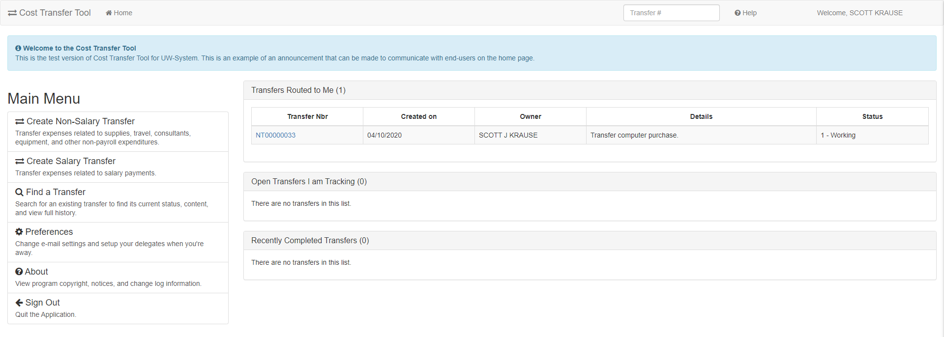

Searching for Transfers
- Click on Find a Transfer while in the Dashboard
- On the “Find a Transfer Screen” users:
  - Can search for completed transfers
  - Can search for transfers in process
  - Can use multiple filtering options (e.g. Project ID)
  - Can search for any transfer, not just transfers prepared by you, and view comments, documents, preparer, approvers, etc.…
** Eliminates the need to print a copy for your file **
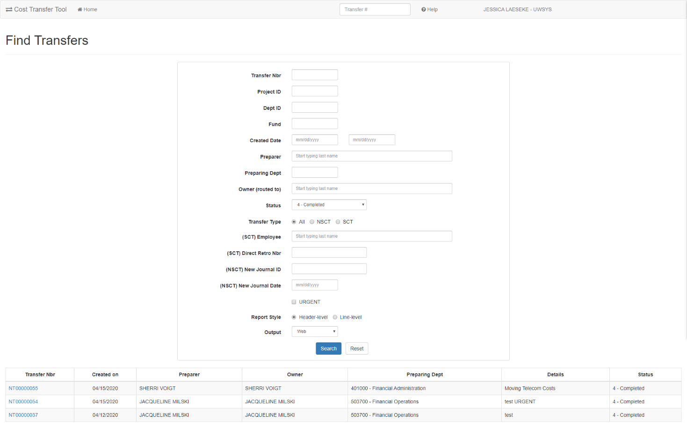

Validations
Cost Transfers undergo a series of validations to ensure that all data is valid and clean. If any of these rules are violated, the tool informs the user and halts any further processing until the corrective actions are taken. The following high-level validations are performed:
- Debits and credits must be equal.
- Line descriptions must be filled in.
- The “from” amount cannot be greater than the original posted amount and cannot be zero.
- The transfer cannot be empty (it must have at least one set of balanced transfer items).
- For any transfers older than 90 days must have a standard 90-day justification form filled out.
- Transactions cannot be transferred a second time. For example, if 100% of the amount of an original transaction is transferred, the tool keeps a record of this and disallows any further transfer. Any remaining amount from a previous partial transfer is eligible to be transferred, however.
- Budget accounts, balance sheets (such as liabilities, deferred expense, Accounts Receivable, etc.), or revenues accounts are not allowed. In other words, it must be an expenditure.
- The sign of the “from” amount must be preserved in the negated form (for example, if the original posting was for $1, the “from” amount must be -$1.). This prevents the user from flipping the sign accidentally.
- Transfers are limited to 50 total sets. Transfers larger than this usually must be handled via a custom journal posting through JET (Journal Entry Tool) via Accounting Office.

Workflow After Submitted
- Once the transfer completes all entry and passes validations, it then moves on to the next step – review and approval by a person.
  - User Entry Wait for Approvals Pending Posting Posted/Complete
- The record can be returned to the preparer any point to be revised or deleted
- The approvals process is dynamic and depends on the content of the transfer itself.
- One core concept in Cost Transfer workflow is the idea of an approval “tier”.
  - Tiers are ordered so that the first tier must be fulfilled before the second tier, and that must be fulfilled before the third and so on. This ensures that the next level tier does not see the transfer on their work lists until it is ready for them to sign.
  - Upon a rejection, the rejection usually goes to the previous tier where it must be corrected or deleted by the preparer.

Person Resolution
The final component of the workflow process is person resolution. This refers to the process that the tool uses to resolve who can sign on a given approval item. It is important to note that when each new tier opens, the resolution process runs. This means that the approval item is not tied to a specific person until they sign. The person or persons that are determined to sign is delayed until the last possible moment and is not computed at the time the transfer is submitted.

Other Aspects to Workflow and Approval
- When a record is rejected and goes back to be edited, upon submission a second time, existing signatures made prior to rejection are preserved. The system “fast-forwards” to the highest, unsigned tier at that time.
- It is possible for a division approver to make their own transfer and sign it as well. There is no conflict of interest considered.
- If a person is away on vacation or leave, a back-up signer can be made (a delegate). That person can sign as in lieu of that person and this fact is recorded on the approval item. Delegates can be effective dated as well.

