Using the Web Portal for Work Requests
& Viewing Work Order Charges

Entering a Request:

Open any web browser. Navigate to the FP&M Home page or enter the following URL: http://www.uww.edu/adminaffairs/fpm/. Select the “Work Requests” box.
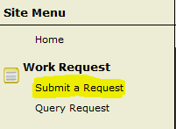

On the left side of the page, under the heading Work Request,
select “Submit a Request”

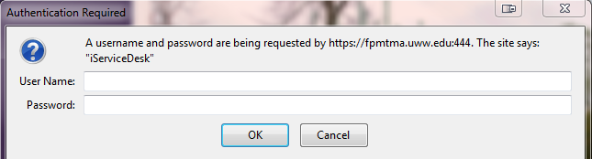
Enter your user name and password (netid and password) – click OK

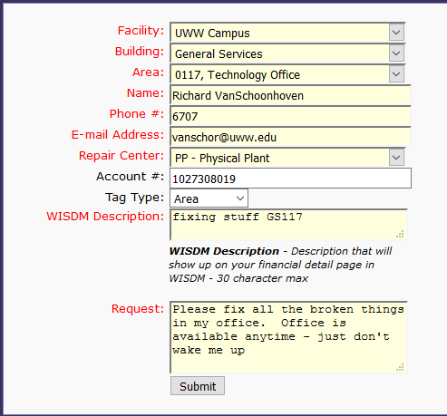
Fill in the fields as follows – using the pull-down arrows when available

Facility Most customers will select “UWW Campus”
Building Select the building where the work is
to be done
Area Select the area where the work is to
be done, note that there are codes
towards the bottom of the list for “Entire floor” – you can use if the work involves multiple rooms.
Name Enter the contact person’s name
Phone # Enter the contact person’s phone #
E-mail Address Enter the contact person’s e-mail
address. Enter as (name@uww.edu)
Repair Center Select one of the following Repair
Centers – the other codes are used by
Facilities staff

Repair Center Selection Guide
PC – Chargeable:
This should be selected for all chargeable work requests.
Ex: build new computer lab, hang picture, etc.
Refer to Chargeable vs Non-Chargeable document (attached) for further clarification.
PP – Physical Plant:
This code should be selected for all routine maintenance requests in any academic or office building.
UC – University Center:
This code will be used for all work requests in the University Center that are non-chargeable.
UH – University Housing
This code is no longer used – for Housing issues please contact the University Housing Office
Account # Enter the full 10 digit code to be charged along with the Project Code if applicable. Account Code MUST be provided for all PC Repair Center requests
Tag Type/Tag # Used internally by Facilities staff – leave defaulted to Area.
WISDM Description Enter a short description – this will be what shows up on your WISDM page
Request Enter the details of the work you are requesting. Be as descriptive as you feel you need to be. If there are special circumstances (Room availability, etc) please include them here
Click on Submit
A new screen will open and you will see your Request #. You can reference this Request # when following up with Facilities.

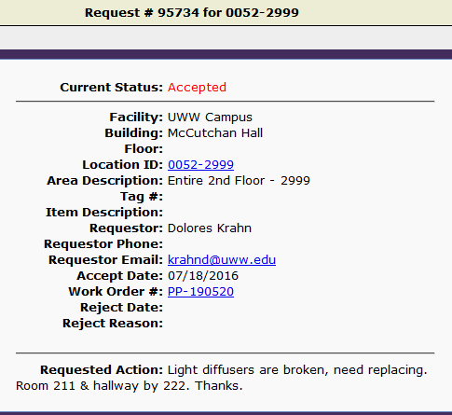

When the Request is accepted and converted you will receive an e-mail with your Work Order #.

Viewing Work Order Detail & Charges

Open any web browser. Navigate to the FP&M Home page or enter the following URL: http://www.uww.edu/adminaffairs/fpm/. Select the “Work Requests” box.

On the left side of the page, you will see Search by Number. You can search by your original Request # that you received when you submitted the request. Or, you can use the PREFERRED METHOD which is searching by your Work Order # that you received by e-mail after Facilities accepted your request. In this document, we will focus on searching and viewing using the Work Order #. Enter your number – if entering a work order #, be sure to enter the entire number, including the dash

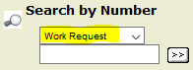
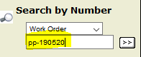
PREFERRED Click on the >> to proceed
METHOD

In the upper right hand corner of the page, you will see two options.

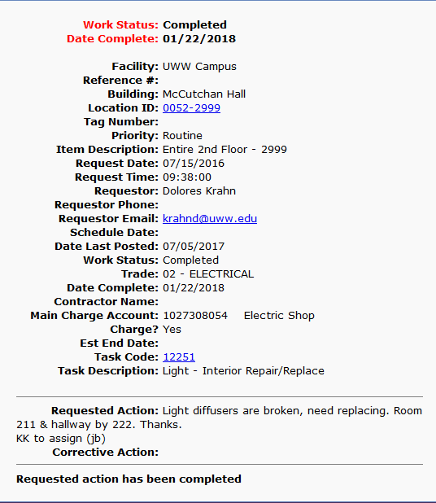

Print page

Prints the page that is currently displayed – this is a summary sheet, which includes the last date charges were posted against this work order, completion date, and any technician notes.

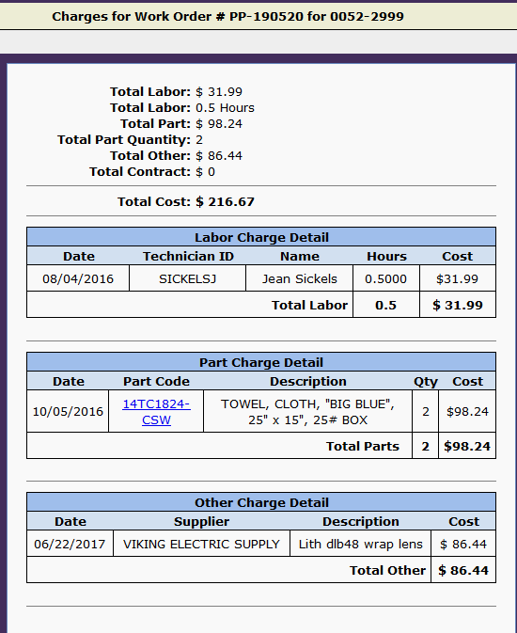

View Charges

This page will give the actual charges for the job including labor, parts from the UWW Warehouse, and other parts that were used.

You can also print this page if desired.

Facilities Planning & Management
Non-Chargeable vs Chargeable Work

This document is meant to provide a GENERAL guideline for the services that Facilities Planning & Management (FP&M) provides to the UW-Whitewater campus community. This document will provide you general information as to what is considered non-chargeable work versus what is considered chargeable.

Non-Chargeable Work:
Routine repair and maintenance of building interior and exterior of any fixture or component that was provided by the original building construction project, or any subsequent State of Wisconsin funded remodeling project. Some examples of non-chargeable work:

Any HVAC system repairs Elevator repairs
Plumbing repairs Classroom furniture repairs
Electrical system repairs Williams Center pool maintenance
Maintenance painting per schedule Grounds maintenance
Window air conditioner repairs (policy change 2004)

Chargeable Work:
Maintenance, repair, or assembly of “departmentally owned” items which were purchased and installed separately from the original construction budget. Some examples of chargeable work:

Repairs to lounge equipment (stoves, etc) Departmental furniture moves
Key cutting for any lost keys Re-keying any functionally working lock
Replacement of carpet Installation/repair to any departmental equipment
Renovation/remodeling Painting (outside of maintenance schedule)
Window treatment repairs/installation Table/chair rental & setup/teardown
Custodial services for special events New window air conditioner purchase

Is this chargeable? Y N Is this chargeable? Y N
Office is cold/warm |  | X |  | Hang picture/plaque | X
Water fountain not working |  | X |  | Make office signs or nameplates | X
Toilet, sink, urinal repairs |  | X |  | Move office furniture | X
Install new water line for coffee maker | X |  |  | Departmental equipment repairs | X
Office, hall, or exterior overhead light |  | X |  | Office furniture repairs | X
Desk lamp needs repair | X
Light switch or outlet not working |  | X |  | Repair ceiling tiles, base cove, etc |  | X
Install dimmer switch | X
Fuse blown, power outage |  | X |  | Door lock not working |  | X
Install new data, phone, electric line | X |  |  | Re-key door | X
Repair existing communications line |  | X |  | Unlock file cabinet, desk, etc | X
Elevator not working |  | X |  | Handicap door not working |  | X
Fire alarm going off |  | X
Install projector, new lighting, etc | X |  |  | Window air conditioner repairs |  | X
“Common Area” clock repair |  | X |  | Table, chair, or risers rental | X

