2020 Employee Wellness & Benefits Events
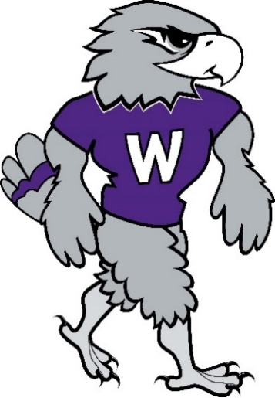

Wellness Initiative
StayWell Million Step Challenge
- Send your team roster with your team name, team captain, and team members to benefits@uww.edu
- Challenge ends on October 9th, 2020
Mindful Gratitude Speaker | September 30th, 2020 from 12PM – 1:30PM | Via WebEx | To register, please email benefits@uww.edu
Nature WINGO – This year’s version of WINGO is all about getting outside, going for a hike, visiting a park, and enjoying nature. We have designed a WINGO card with 16 different parks, trails, gardens, and more.
- Email benefits@uww.edu to receive your WINGO card & compass carbineer for signing up
- Runs from July 15th – November 15th
Upcoming 2020 Benefit Events
Biometric Screenings:
- Will take place on September 25 & 30 at the CEC
- Examiners will be on campus to administer health screenings
for the $150 incentive program.
- Appointments required – employees can sign up in their StayWell Portal
Open Enrollment 2020:
- Open enrollment will be September 28 – October 23, 2020
Benefits Fair:
- The 2020 Benefits Fair will be virtual this year. More details to come
Benefits Enrollment Assistance Sessions (BEAS):
- Will be offered on October 6th, 14th, and 23rd at the CEC
- By appointment only, more details to come
Flu Shot Clinic
- Tuesday, November 3rd in UC 68 & Thursday, November 5th at Rock County Campus
- A nurse from StayWell will be on campus to administer flu shots to employees
- Appointments are required, a sign up will be sent out soon

