- Click the following link to Navigate to SFS, https://portal.sfs.wisconsin.edu/
- On the SFS homepage, click the Security Role Request tile.

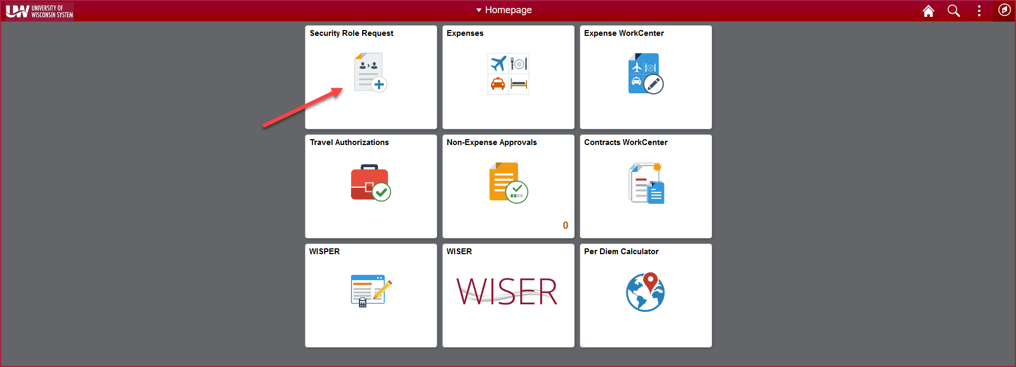

- On the Security Role Request landing page, click on the Add Security Role Request link to the left of the page.

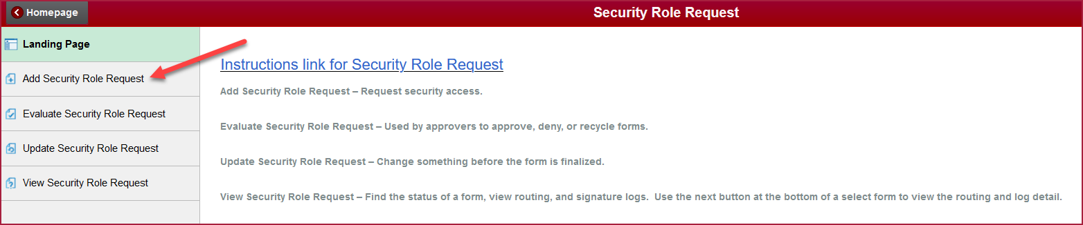

- Enter search criteria for the individual for whom you will be requesting access. This could be for yourself or someone else. Click the Search button and select the user.

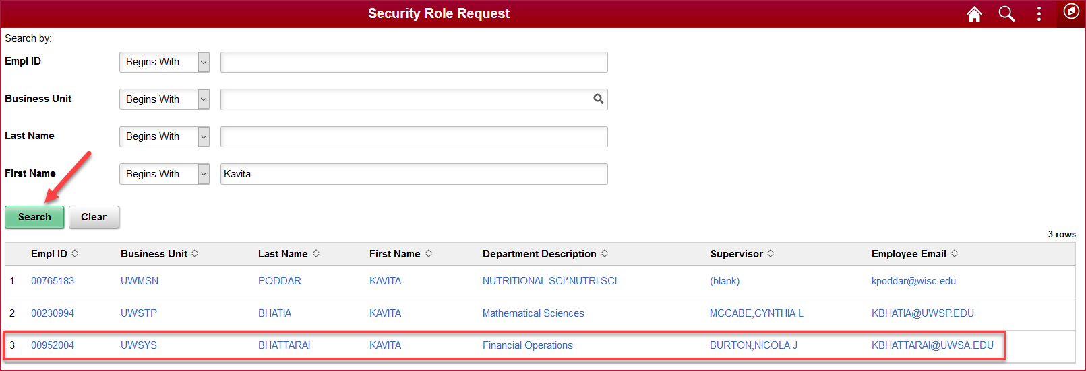

- The Security Request Form will populate with the requestor, the user receiving access, and the user’s supervisor if available. If the supervisor is not shown, click the magnifying glass to search.

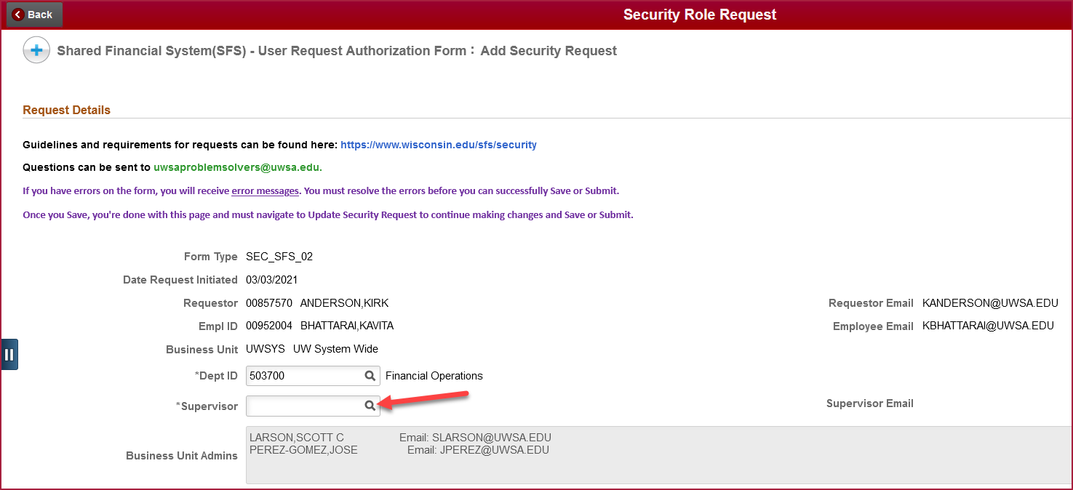

- Click Search Criteria to expand the search section. Enter information for the supervisor and click Search. Select the user’s supervisor.

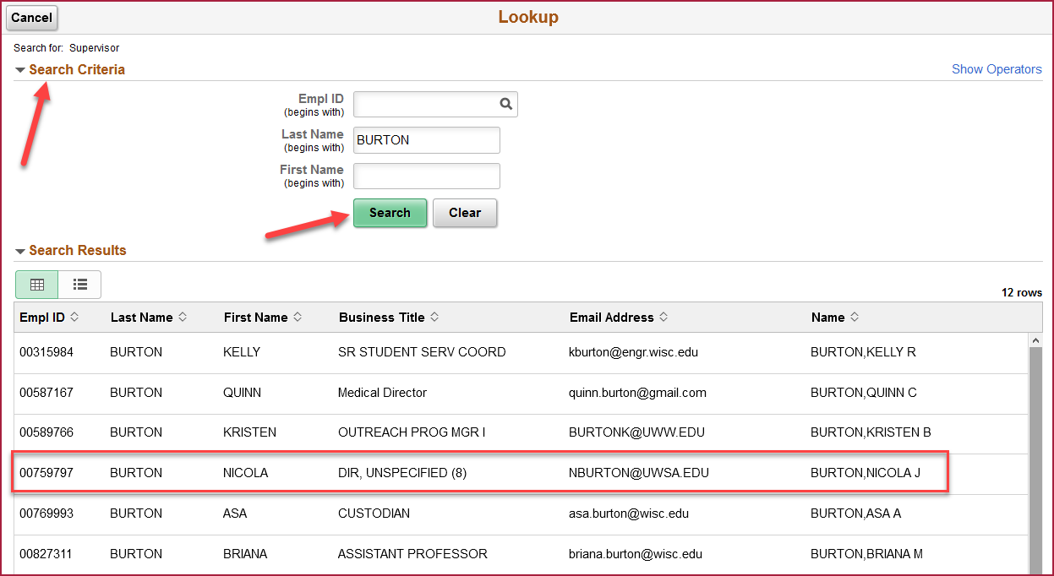

- Select whether the access will be for SFS Production, Test environments, or both. For a list of security roles by module, click the Role Catalog hyperlink. To view roles currently assigned to the user, click the Look-up User Roles hyperlink. If needed, enter comments regarding why the access is being requested.

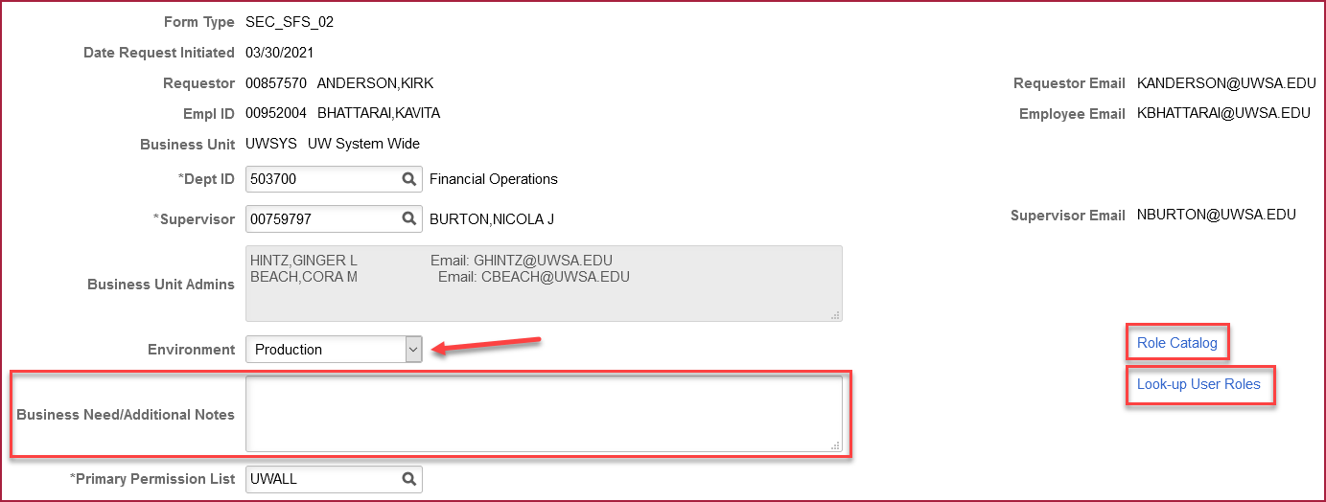

- In the Roles to be Added/Removed section, enter the roles, and the action that should be taken (Add or Remove). To search for a role, click the Magnifying glass under Role Name.

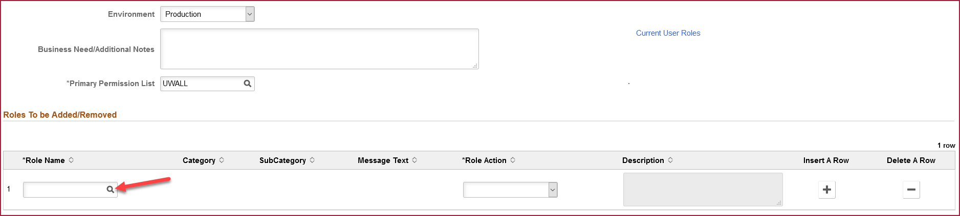

- Click Search Criteria to expand the search section. Click the magnifying glass next to Category and select General User.

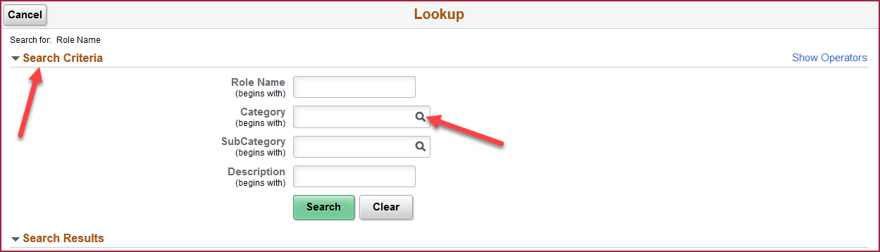

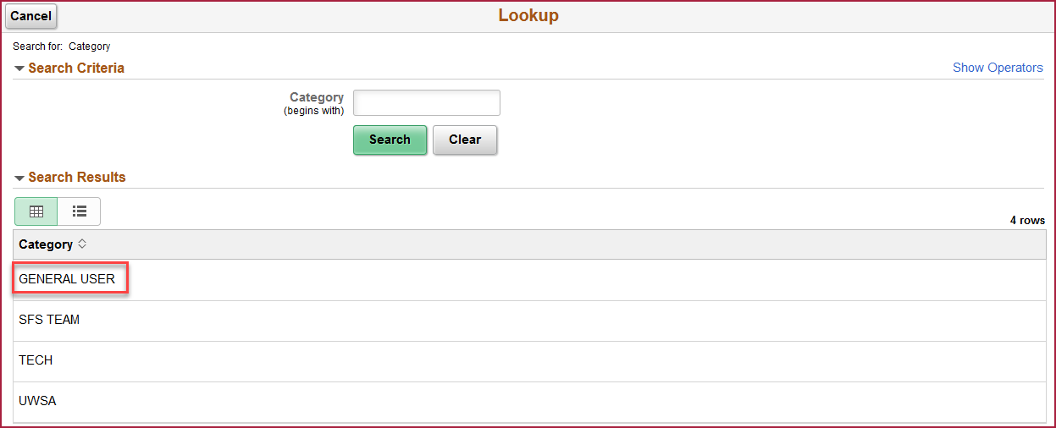

- Click the magnifying glass next to SubCategory. Select the SubCategory for the role that will be added/removed.

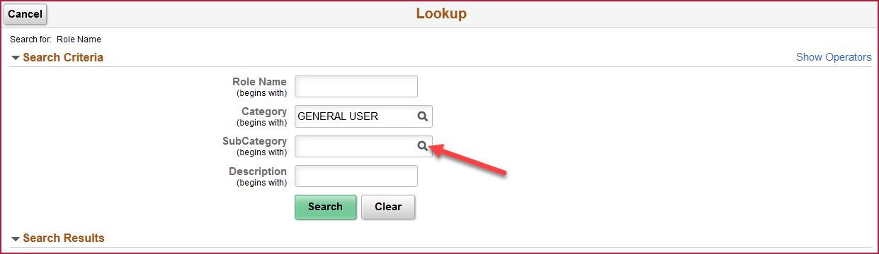
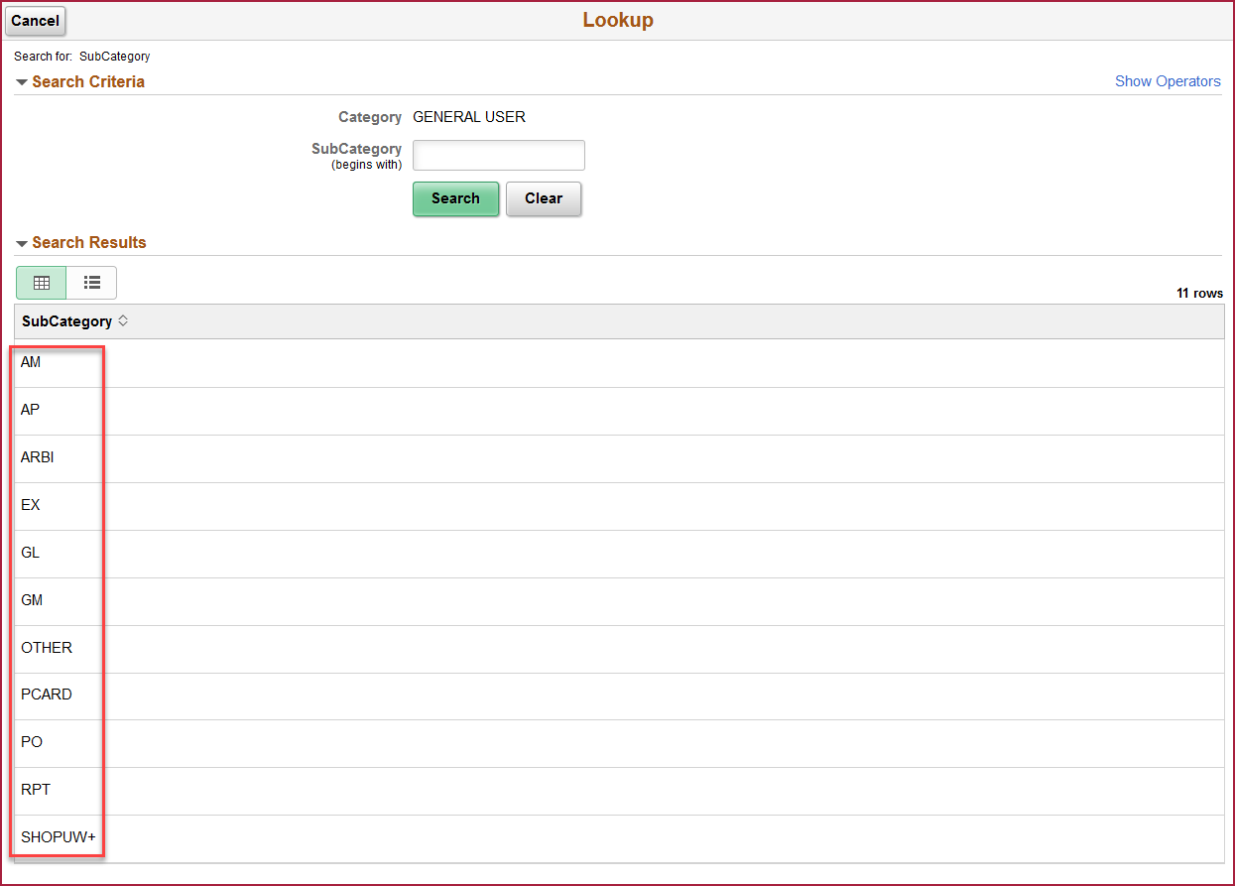

- Click Search and the roles under that Category/SubCategory will be shown. Select the role to be added/removed.

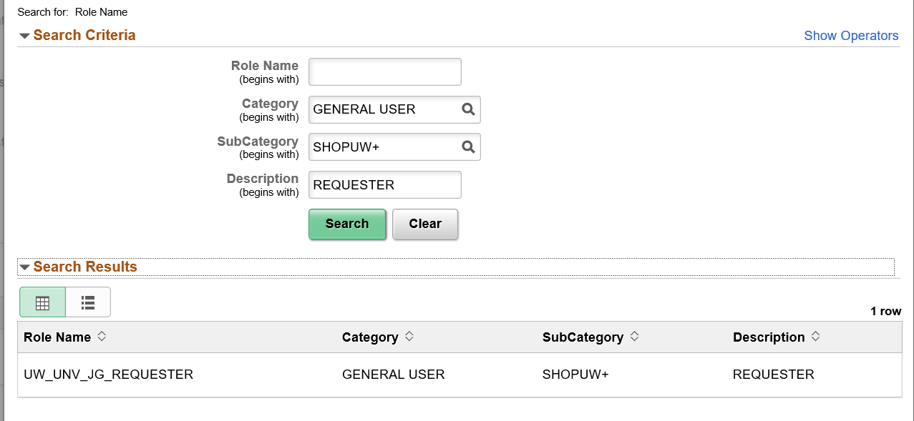

- Select the action to be taken, either Add or Remove. Review the role description to confirm that the correct role was selected. Note that certain roles have been deemed high privilege and will require additional approval from either the financial director or technical manager. If additional roles are needed, click the “+” button and repeat steps 8-11.

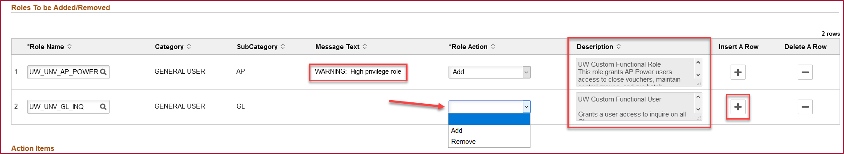

- If you are requesting access for yourself, change the acknowledgement button to Yes, agreeing to the terms of the form. If you are requesting access for someone else, they will acknowledge the terms when the form is routed to them for approval.

If needed, expand the Comments section to add any additional notes regarding this request. Click the Submit button to begin the approval workflow process.

If you are requesting access for yourself, an email will be sent to your supervisor, asking for their approval. If you are requesting access for someone else, the approval request will first go to that individual and then to their supervisor.

