Wisconsin Sound Beginnings Camp 2025 is almost here!
Be sure to review this information as you prepare for your arrival.

Check in and Out Information
Activity | Date | Time | Location | Notes
Check-In | Friday, July 25, 2025 | 9:00 – 11:00 am | Pulliam Hall
Check-Out | Sunday, July 27, 2025 | 1:00 – 2:00 pm | Pulliam Hall
Calculate your travel time using our maps and directions.

Introduction
We are excited to meet all of you in person! Coming to a full weekend to join others, to play and learn together, can bring up various emotions. Excitement, nervousness, worry, etc. This is very understandable. We hope this packet answers questions and offers ideas for how to prepare, both you and your children.
Families will be joining us from across Wisconsin with children ages 0-5 who are DHH. We look forward to this wonderful gathering together! Our staff, including Support Parents and Deaf/Hard of Hearing Ambassadors and Mentors, will be sharing personal stories that may feel vulnerable. We hope you will be open to sharing too. We trust that everyone will be non-judgmental in people’s choices and open to ideas and shared learning experiences together. We hope by the end of the weekend, you feel connected and energized.
Schedule of activities: throughout the weekend children will be in close proximity to their caregivers. Staff will be wearing black t-shirts, and are available to help, so please feel free to ask.
There will be two photo release forms for you to sign when you check-in.
Included in this packet you will find bios and pictures of all the staff/volunteers, a campus map, a schedule of events for the weekend, a description of the family suites at Pulliam dorm, and a packing list.

Important Phone Numbers
Person | Phone Number | Notes
Lauren Burke | 608-280-1148 | Camp Coordinator
Chrissy Vorreyer-Davis | 304-240-2320 (text only) | Camp Coordinator
Chris Kometer | 414-807-0498 | Camp Coordinator
Health Staff/Athletic Trainers | 920-723-8736  920-723-8726  920-723-8724 | Athletic Trainers/Health Staff available on campus during camp.
University Housing | 262-472-4200 | Mon-Fri 8:00am-9:00pm  Sat-Sun 9:00am-7:00pm
UWW Campus Police | 262-472-4660 | Non-emergency number for after 11:00pm needs.
Emergencies | 911 | Medical, safety, or environmental emergencies.
Fort Memorial Hospital | 920-568-5000 | Nearest hospital to campus.  611 E. Sherman Ave., Fort Atkinson, WI 53538

Parking
Please visit uww.aimsparking.com and follow these steps to redeem a free parking pass:
- Select: Purchase UW-W Special Events Permits
- Agree to Terms of Service
- Select Event Type: CAMPS
- Select Event: 07/25 – 7/27 – Wisconsin Sound Beginnings
- Enter Voucher Code: WW2025CES
- Select Permit Type: 25-CAMPS 2025
- Dates will automatically fill in.
- Click “Add Vehicle”
- Enter the license plate, make, model, and color of your vehicle. Click “Add”.
- Follow the remaining prompts to complete the registration process.
Please feel free to park in the lot closest to the Residence Hall. Permits are required for all vehicles dropping off, picking up and staying on campus.

Camper Safety

Health Service:
Parents/Emergency Contact will be called for advice and recommendations if the problem does not require immediate medical attention. Should you require medical attention, the camp health supervisor will assess appropriate measures to take. UW-Whitewater camps have the full cooperation of Fort Memorial Hospital and emergency room personnel. For participants taking medication, please complete the health form prior to arrival. When possible, the Athletic Trainers and health staff will contact parent(s)/guardian(s) before seeking treatment.
You will be required to provide health information in the registration. Athletic Trainers and health staff will refer to the registration whenever medical treatment is necessary; this is the only guide a health care provider will have in case of an emergency.

Injuries during Camp:
Should an injury occur the event director will seek medical attention from UW-Whitewater Athletic Trainers or call 911 in a medical emergency.
After the registrant is being cared for, the event director will report to the Youth Compliance Coordinator with details on the injury. The event director will distribute the Injury Claim Form to the injured participant and their family. Forms and information can be found under Camps and Clinics Forms by clicking the link above.
The Youth Compliance Coordinator will notify UW-Whitewater Risk Management of the incident/injury.
The injury claim form is submitted to Gallagher by the parent; Gallagher then submits the injury claim form to HSR (Claims Company for accident policy).
HSR will contact UW-Whitewater Risk Manager to authorize the incident via phone or email.
Upon confirmation of the covered claim, HSR will add the injury to their claims system so that corresponding medical bills will be eligible for coverage.

Dining/Dietary Services:
All campers will be served lunch and dinner. Any special dietary needs and questions can be accommodated/answered there by Summer Manzke, Campus Dietician, at Summer.Manzke@compass-usa.com or 920-650-4239.

Inclement Weather:
In the event of inclement weather, Camp Directors will move campers to identified safe spaces on campus. Campus police and Continuing Education support each camp in communicating potential storms and developing a plan to ensure participant safety.

Excessive Heat:
Participants are advised to bring fans. Note: The gymnasiums are also not air-conditioned. Greenhill Center of the Arts, Moraine Bookstore, Upham Hall, University Center and dining halls are air-conditioned. During periods of heat, directors will provide a cool area for participants and will take all the necessary precautions to avoid heat fatigue. This may include cancelling awards ceremonies in the gymnasium. Participants are advised to bring fans, as many of the residence halls are not air conditioned.

Camp Packing List:

Pulliam Hall – Bedrooms

Linen pack will be provided: contains fitted sheet, flat sheet, thin blanket, 1 large towel, and a pillow case (but no pillow provided).
- Pillows for all attendees
- Blankets or additional bedding beyond the linen pack.
- Porta-crib, pack-and play, toddler travel beds - there is space for 1 portable crib in each bedroom.
- Favorite blankets, stuffed animals, toys, etc.

Pulliam Hall – Kitchen/Living Room/Bathroom

Toiletries (toothbrush, shampoo, soaps, etc.)
- Additional towels beyond the 1 provided in the linen packet (large towels, hand towels, and washcloths)
- Dish soap, sponges (for washing your own dishes)
- Hand soap
- Plates, bowls, cups, utensils
- Snacks, food for early mornings or downtimes
- Tablet or laptop - no TV in suites, wifi available
- Families can bring their own coffee pot or hot plate if they would like
- Phone charges
- Games, toys, activities for down time in your room

Clothing

Clothing for outdoor and indoor learning and playing
- Extra clothes in case of rain, waterplay
- Pajamas
- Comfortable shoes
- Sun hats, sunglasses

Personal Items:
- All toiletries needed (ex., shampoo, conditioner, soap, lotion)
- Toothbrushes, toothpaste
- Sunscreen
- Any personal medications
- Hand sanitizer, wet wipes
- Diapers, wipes
- Basic first aid kit
- Baby monitor

Exploring Campus:
- Stroller, wagon - there will be a lot of walking between different places on campus
- Baby carrier
- Water bottles for filling and keeping hydrated
- Snacks - families will need to bring and provide their own snacks during the weekend. Meals will be provided (Breakfast, Lunch, and Dinner).
- Sunscreen, hats, shoes for running and playing
- Backpack for carrying materials to different locations across campus

Camp Schedule:
ALL EXPERIENCES ARE OPTIONAL BASED ON THE NEEDS OF YOUR INDIVIDUAL FAMILY

Friday, July 25, 2025
Time | Activity
9:00 – 11:00am | Check-in, Move into Dorm
11:00 – 12:00pm | Welcome and Family Activity
12:00 – 12:45pm | Lunch
1:00 – 1:45pm | Family Activity Options:  - Family Art Activity  - Mingling and Connecting  - Nap Time Opportunity
2:00 – 3:00pm | Parent Session – Panel: DHH Experience Ambassadors  Children – Activities with Adult Staff/Volunteers
3:15 – 4:00pm | Parent Program – Shared Reading  Children – Activities with Adult Staff/Volunteers
4:00 – 4:30pm | Parent-Child Activity Together: Shared Reading
5:30 – 7:30pm | Dinner: Pizza  Share Reading Activity and Ice Cream Party  Family Activities & Playground

ALL EXPERIENCES ARE OPTIONAL BASED ON THE NEEDS OF YOUR INDIVIDUAL FAMILY

Saturday, July 26, 2025
Time | Activity
7:30 – 8:30am | Breakfast
9:00 – 10:00am | Parent Program – ASL and Spoken Rhyming & Rhythm  Children – Activities with Adult Staff/Volunteers
10:00 – 10:45am | Parent-Child Activity Together – Rhyming & Rhythm
11:00 – 12:00pm | Break: Outdoor playground (weather depending) & Indoor Gym
12:00 – 12:45pm | Lunch
1:00 – 2:45pm | Family Activity Options:  - Mingling and Connecting  - Family Art Activity  - Parent-Child Literacy Activities  - Nap Time Opportunity
3:00 – 4:00pm | Parent Program – Parent Panel  Children – Activities with Adult Staff/Volunteers
4:00 – 5:00pm | Family Time – Open Time
5:00 – 6:00pm | Dinner
6:00 – 7:30pm | Family Fun Night – Bowling, Games, Activities

Sunday, July 27, 2025
Time | Activity
7:30 – 8:30am | Breakfast
9:00 – 10:00am | Parent Sharing Circle  Children - Activities with Adult Staff/Volunteers
10:30 – 11:00am | Closing Gathering & Group Picture
11:00 – 12:00pm | Energy Release Before Travel:  - Outdoor Playground/Indoor Gym  - Pack up Dorms
12:00 – 1:00pm | Lunch
1:00 – 2:00pm | Check out, Move out

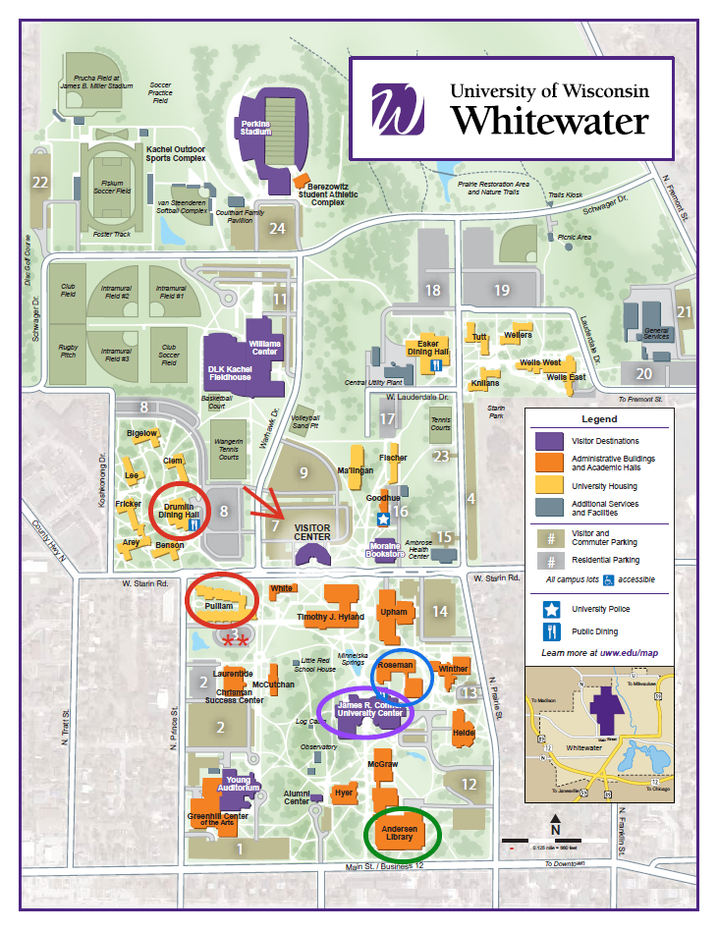

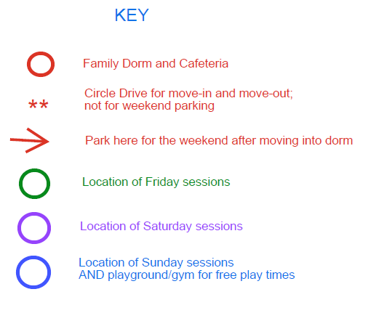

Pulliam Hall
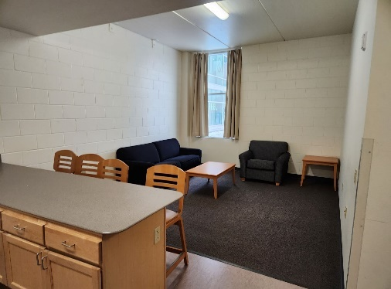
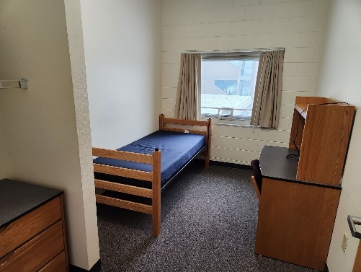
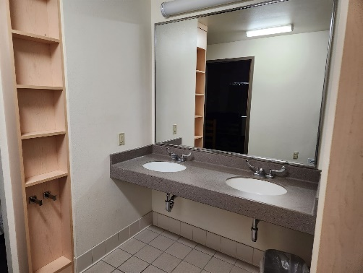
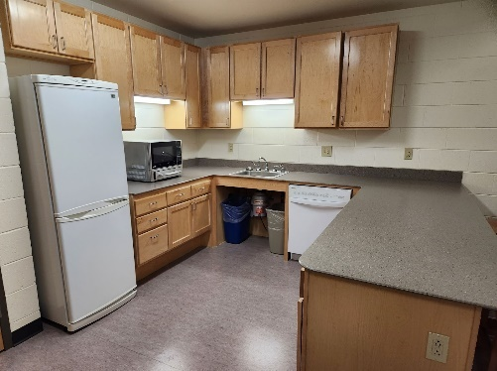
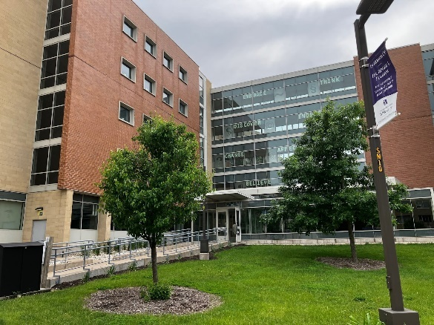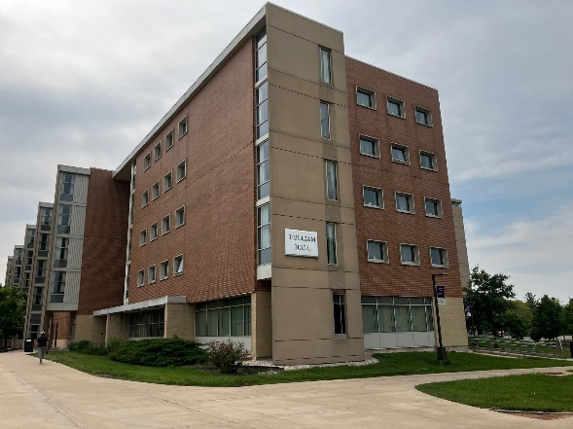

- Each family suite has 1 main door (families will be given a key).
- Inside each suite are 4 individual bedrooms, each with a twin size bed, desk, dresser.
- Each suite has it’s own private bathroom with toilet, sinks, and shower.
- Each suite has a kitchenette with a full size fridge, a countertop microwave/oven, a dishwasher, stools to eat at a countertop.
- Each suite has a living room space with a couch, chair, and small table. There is no TV.
- At check-in, families will receive a key to their family suit and a linen sets for each participant (each linen set includes: 1 fitted sheet, 1 flat sheet, 1 pillow case, 1 light blanket, and 1 large towel).
- There is a location to park and unload your car right outside of Pulliam Hall. After unloading, you will need to move your car to the visitor parking lot for the weekend.
- There is an elevator to reach the 5th floor where all families will be staying.
- The building is air-conditioned
- On the main floor of the building, there is a lobby and an activity room (TV’s, ping-pong table, pool table).
- A large courtyard with space to walk and play is located right outside the building.
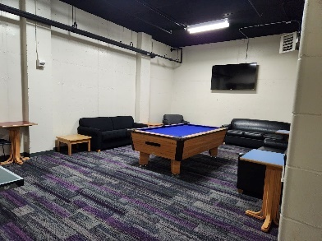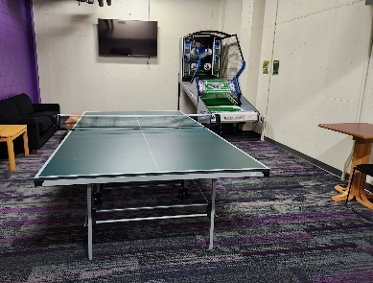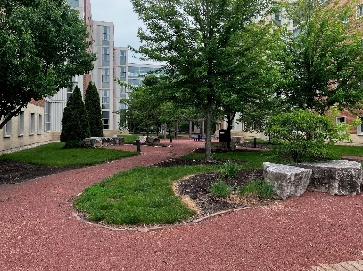
Meals
- Meals will be provided throughout the weekend at no cost to families.
- Breakfasts will be provided at Drumlin dining hall on Saturday morning 7/26 and Sunday morning 7/27. The building is located across the street from Pulliam Hall.
- Please bring strollers or wagons for getting to different locations across campus.
- Lunches and Dinners will be provided at various locations depending on the schedule
  - Lunch Fri 7/25 – Drumlin Dining Hall
  - Dinner Fri 7/25 - Starin Park
  - Lunch Sat 7/26 - University Center
  - Dinner Sat 7/26 - University Center
  - Lunch Sun 7/27 - Drumlin Dining Hall
- Families are encouraged to bring your own snack options for your little ones to eat throughout the weekend. Campus does not have baby/toddler options to purchase. While meals are provided, we are not able to provide any snacks in between designated meal times. Families will have a full size refrigerator in their Pulliam hall rooms. Please plan to bring snacks, early morning bites, or late night nibbles that best meet your families needs. Please bring them with you throughout the weekend activities so you have items ready when your child needs a quick snack boost.

Participant Code of Conduct
As a participant, I agree to the following statements. I will…
• Respect differences of all participants and will not discriminate against anyone else on
the grounds of gender, race, sexual orientation, ability, or other identity
• Report any incidents of bullying to adults immediately
• Support and encourage all other program participants
• Respect all staff, directors, and volunteers
• Follow online safety and internet use policies
Prohibited Conduct:
• Abusive language towards a staff member, volunteer, or another participant
• Bringing dangerous or unauthorized materials such as explosives, firearms, or weapons
onto to campus property
• Inappropriate or rude treatment of a peer, staff member, or volunteer
• One-on-one interactions with any program staff member before, during, or after any
program
• Verbal, physical, or visual harassment of another participant, staff member, or volunteer
• Actual or threatened violence toward any individual or group
• Conduct endangering the life, safety, health, or well-being of self and others
• Failure to follow any UW System or campus policy, including but not limited to sexual
assault/violence/harassment policies, dishonest academic behavior policies, or
emergency procedures
• Bullying or taking unfair advantage of any participant
• Failure to follow directions of supervisors/youth programming staff/event leaders
• Possession or use of alcoholic beverages or illegal drugs on campus property or
reporting to the program while under the influence of drugs or alcohol

